Using a SmartCharger with the K2 Internal Battery

Don Wilhelm W3FPR

I had been using my K2 with the internal battery option for about a year, and had tried several power supplies with it, and I found that those I could adjust to an output of 14.4 volts were capable of keeping my internal battery charged in normal use. While these power supplies placed 13.8 volts at the battery terminals (float voltage for a 12 volt SLA battery), after a discharge cycle, it would take a long time (several days) at the float level to fully recharge the battery.

My research into the care and feeding of SLA batteries indicated that the most common mode of battery failure was as a result of undercharging. Not wanting to sacrifice my battery’s life, I decided to invest in a SmartCharger to keep the charge topped off. There are several on the market, but I chose the kit by A&A Engineering for the purpose. This is a 3 stage charger available assembled in 1 amp and 2 amp versions, or a kit which is programmable for ½ amp or 1 amp output with the parts supplied, but can be changed to any current rating by changing one sensing resistor.

I chose to set my charger to 250 ma to prevent overcharging the battery during periods when my K2 was turned on and the battery was already charged. During receive my K2 draws approximately 250 ma, so when the SmartCharger switches into bulk charge mode (the charger sees only a current draw with the K2 on, and thinks the battery needs to be charged), the K2 takes all the current the SmartCharger can supply and no current flows into the battery. Naturally, during transmit periods the battery will become discharged, but will be recharged after the K2 is turned off. If your operating periods are normally long compared to the time your K2 is turned off you may want to set your charger for ½ amp. The potential for damaging the battery with only 250 ma of current during times when your K2 is turned on is quite small (according to the battery manufacturer’s information).

Using a SmartCharger requires a direct connection to the internal battery, but the K2 uses a protection diode as well as the resetable fuse in the power connector path. I wanted a fused direct connection to the battery with a connector on the rear panel. I found the space cramped since I already had the KAT2 installed in addition to the internal battery and I did not want to sacrifice the existing holes for the transverter option. The figures show how I fit it all into the top cover.

I bought only 4 parts:
Inline Fuse Holder – RS 270-1238c or Mouser 44FH498
Fuse – 5x20mm, 2 Amp Fast-Acting – RS 270-1052 or Mouser 44FM052
Coaxial DC Power Jack – 5.5mm OD x 2.1mm ID – 21/64” hole – RS 274-1582 or Mouser 163-4304
Coaxial DC Power Plug – 5.5mm OD x 2.1mm ID – RS 274-1569A or Mouser 1710-2111
Tie-Wraps or suitable substitute and a 10 inch length of #16 wire are also needed.

The first step was to drill the hole in the top cover. My choice for this hole was next to the External Speaker jack. I first used a Post-it note to shield the KAT2 from any metal chips that may be produced, drilled a pilot hole and finished with a 21/64 inch drill bit. The outside of the hole was de-burred with a larger size drill, and a utility knife de-burred the inside. I could have removed everything from the top cover for this drilling procedure, but I took the ‘lazy’ way out.

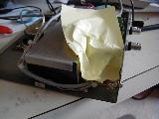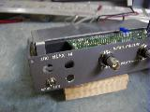
Chip Protection Shield The new connector hole
Disconnect both Faston connectors from the battery terminals and cover the battery terminals with tape to prevent any accidental shorts.

The next step is to mount the connector. Orient the connector so you can solder to the terminals. The third terminal for the internal switch is not used.

The leads on the inline fuseholder were just long enough to solder one end to the connector center pin and to place the body of the fuseholder around the corner of the battery. Be certain that there is enough slack to allow separating the fuseholder for fuse replacement. The other end of the fuseholder is soldered to the Faston connector at the positive terminal of the battery. I was successful in re-using the original Faston connectors for the battery (with the help of some shrink tubing), but you may want to use new ones – it will be easier.

Solder a #16 wire to the shell side of the new connector and dress it around the end of the battery. Solder the other end of this wire to the Faston connector at the negative side of the battery. Be sure there is enough slack to get the Faston on and off the battery terminal.

Dress the wires in place and secure to the other wiring with Tie-Wraps or other suitable devices. Place the terminals on the battery and you are ready to roll. Put the K2 top cover back on. The photos below show what mine looks like.

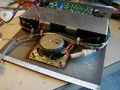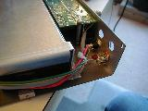
Wire dressing New connector wiring

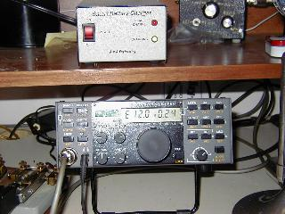

My K2 with the A&A SmartCharger

Modifying the A&A SmartCharger for 250 ma. bulk current.

The A&A Engineering charger kit is supplied with two 0.5 ohm resistors which will control the bulk current. The stock instructions tell you to install one at position DS1 for ½ amp out and install the second one at DS2 for 1 amp output (DS1, DS2, DS3 and DS4 positions are connected in parallel). To obtain my desired 250 ma. output I needed a 1 ohm resistance. A careful examination of the circuit board told me that if I made 2 cuts and added one wire I could connect the two 0.5 ohm resistors in series and have my 1 ohm total resistance. As a bonus, adding a switch across one of the resistors to short it out would allow switching the charger from 250 ma. to ½ amp bulk current – solder pads are available. The cuts and the added wire are shown on the left side of the photo below.

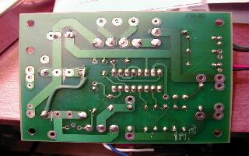

The cut near the center left of the board is just on the right side of the thick vertical trace and the second cut is just to the left of the lower thick vertical trace . Install one of the 0.5 ohm resistors in position DS1 and the other in position DS4 and add the wire as shown to connect the two ends of the resistors that were isolated by the cuts – this places the two resistors in series.

If you wish to add the switch to change the bulk current the wires to the switch would be connected to the pads normally occupied by DS2. The bulk current will be 250 ma with the switch open and 500 ma with the switch closed.

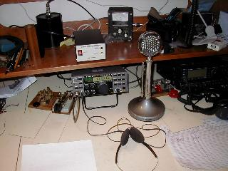

My K2 operating position

